Version <1.0>

Revision History

|  |  |  |  |
| --- | --- | --- | --- |
| **Date** | **Version** | **Description** | **Author** |
| 14/Setember/2014 |  | Fill out the introduction and product overview |  |
| 2/October/2014 |  | Fill out the project organization and management process. |  |
| 2/October 2014 |  | Develop the Gantt Chart |  |
|  |  |  |  |

Table of Contents

1. Introduction 3

1.1 Purpose **Error! Bookmark not defined.**

1.2 Scope **Error! Bookmark not defined.**

1.3 Definitions, Acronyms, and Abbreviations **Error! Bookmark not defined.**

1.4 References **Error! Bookmark not defined.**

1.5 Overview **Error! Bookmark not defined.**

2. Project Overview Error! Bookmark not defined.

2.1 Project Purpose, Scope, and Objectives **Error! Bookmark not defined.**

2.2 Assumptions and Constraints **Error! Bookmark not defined.**

2.3 Project Deliverables **Error! Bookmark not defined.**

2.4 Evolution of the Software Development Plan **Error! Bookmark not defined.**

3. Project Organization Error! Bookmark not defined.

3.1 Organizational Structure **Error! Bookmark not defined.**

3.2 External Interfaces **Error! Bookmark not defined.**

3.3 Roles and Responsibilities **Error! Bookmark not defined.**

4. Management Process Error! Bookmark not defined.

4.1 Project Estimates **Error! Bookmark not defined.**

4.2 Project Plan **Error! Bookmark not defined.**

4.2.1 Phase Plan **Error! Bookmark not defined.**

4.2.2 Iteration Objectives **Error! Bookmark not defined.**

4.2.3 Releases **Error! Bookmark not defined.**

4.2.4 Project Schedule **Error! Bookmark not defined.**

4.2.5 Project Resourcing **Error! Bookmark not defined.**

4.3 Project Monitoring and Control 3

5. Annexes 3

# 

# Introduction

## Purpose

The purpose of this Software Development Plan is to act as a written-detailed guide to all stakeholders, describing all the necessary tasks in the development of the project. The plan serves as a “road-map” to achieve all goals and objectives of the project by identifying individual and group responsibilities and instruction on how each aspect of the plan should be carried out.

## Scope

This *Software Development Plan* describes the holistic plan to be used by the AkiProPlus project. The details of the individual tasks will be described in each

Deliverable plan.

## Definitions, Acronyms, and Abbreviations

DFD- Dataflow Diagram

ERD- Entity Relationship Diagram

## References

Course HomePage(URL): http://myelearning.sta.uwi.edu/course/view.php?id=25738

## Overview

This *Software Development Plan* contains the following information:

Project Overview — provides a description of the project's purpose, scope, and objectives.  It also defines the deliverables that the project is expected to deliver.

Project Organization — describes the organizational structure of the project team.

Management Process — explains the estimated schedule, defines the major milestones for the project, and describes how the project will be monitored.

# Project Overview

## Project Purpose, Scope, and Objectives

Zephrin’s Bakery Inc. is a family-owned bakery business, which supplies bread and pastries to the entire island of Barbados for the past 40 years. They currently employ 120 employees and cater to over 600 customers. Prior to the year 2000 all work was done manually using a pen and paper system. Consequently with the increased volume of data, this created much inefficiency in the company therefore paving the way for the introduction of a new system. Thus in the year 2000 the owner Andre Zephrin contracted Wayne Goodridge to design an application “Aki” to handle the basic running of the business. As time progressed this too became unsuited for the growth of the business and as a result AkiPro was designed and implemented by the year 2012. To give itself a competitive edge over its competitors namely Purity Bakery, the company wants to introduce a more automated and integrated system by incorporating all entities (personals) of the system.

The scope of this project incorporates:

* Rewriting the current application
* Adding additional modules to integrate other entities into the system. These includes

1. Customer being able to have direct access to the system which may involves placing/altering orders and viewing all their transactions in a localize area.
2. Cater for van drivers to do returns from van and to print receipts
3. Allowing merchandisers to gain access to the system to alter standing orders

* Making the application more interoperable with different platforms namely the Android OS, IOS and over the web.

## Assumptions and Constraints

The constraints of the projects are:

* Estimating the difficulty of problems and hence the cost of developing solutions.
* The expertise of the team members.
* Productivity is not proportional to the number and availability of employees to work on a task.
* It is impossible to estimate every problem that may occur.

## Project Deliverables

1. Preliminary Project Plan 03.10.2014

2. Requirements Documentation 17.10.2014

3. Evaluation Report [User Interface] 31.10.2014

4. Architecture Specification 14.10.2014

5. Test Plan 28.10.2014

## Evolution of the Software Development Plan

The *Software Development Plan* will be revised as the project evolves. This includes:

* As more objectives/requirements are known the project plan will be updated accordingly
* The schedule will be updated as necessary to cater for any delay or advancements.
* As the project progresses team leaders will be assigned to accordingly to any new tasks.

# Project Organization

## Organizational Structure

Team Members:

* Sharifa Barrow
* Eka Douglas
* Donique John
* Richard Samuel

|  |  |  |
| --- | --- | --- |
| Week | Deliverables | Team Member |
| 5 | Preliminary Project Plan | Sharifa Barrow |
| 7 | Requirement Document | Eka Douglas |
| 9 | Evaluation Report | Richard Samuel |
| 10 | Architecture Specification | Donique John |
| 13 | Test Plan | Sharifa Barrow |

Table 1: This table shows the team leader in control of each deliverables

## External Interfaces

This project should interact with the following external groups:

* Customers: there are two main types of customer; the walk-in/ cash customers and the repeat/account customers, which can be further divided into weekly and monthly paying customers.
* Merchandisers: There are employees of the customer but are regarded as external entities. Their main interaction with the business is to go around to the different markets to analyze the products, make reports and can suggest any changes to the standing order from any customers.
* Suppliers: They have limited interaction with the application. However there main interaction with the application is to keep record of the purchase orders provided by them so they can be referenced for future purchases.
* Governments (tax suppliers): The application should interact with the government by producing reports, which the government will use to appropriately tax the company.
* Bank: The application should be able to generate reports as requested by the bank that may be used to conduct any future business.

## Roles and Responsibilities

For primary responsibilities per phase, please refer to section 3.1. Ultimately the entire project team is responsible for the successful delivery of the product. Team leaders will assign responsibilities to each member for each deliverables according to their expertise

|  |  |  |
| --- | --- | --- |
| **Deliverables** | **Task** | **Team Member(s) Responsible** |
| Project Plan | Developing project plan | All team members |
| Requirements Document | i. User requirements  ii. System requirements | Richard Samuel, Donique John  Eka Douglas, Sharifa Barrow |
| Evaluation Report | Protyping the user interface | Richard Samuel |
| Specification Architecture | i. Data Flows  ii. ERD  iii. Activity Diagram | Donique John  Sharifa Barrow  Eka Douglas |
| Test Plan | Creating test plans | All team members |

# Management Process

## Project Estimates

The project is estimated to be done in three months as each deliver is estimated to take two weeks to complete. However this estimate may be adjusted as the project progresses primarily after each deliverable.

## Project Plan

The table below shows the estimated schedule of the project

|  |  |  |
| --- | --- | --- |
| **Deliverable** | **Task** | **Date Due** |
| Project Plan | Developing project plan | 03.10.2014 |
| Requirements Document | i. User requirements  ii. System requirements | 8.10. 2014  17.10.2014 |
| Evaluation Report | Protyping the user interface | 31.10.2014 |
| Specification Architecture | i. Data Flows  ii. ERD  iii. Activity Diagram | 7.11.2014  12.11.2014  14.11.2014 |
| Test Plan | Creating test plans | 28.11.2014 |

The primary resource for this project is the four team members. Additional some software applications are also required. These include

* Microsoft Project: to create the Gantt Chart showing the allocation of time for each phase
* Microsoft Visio: to create DFDs, ERDs and Activity Diagrams
* A program to simulate a user interface

### Phase Plan

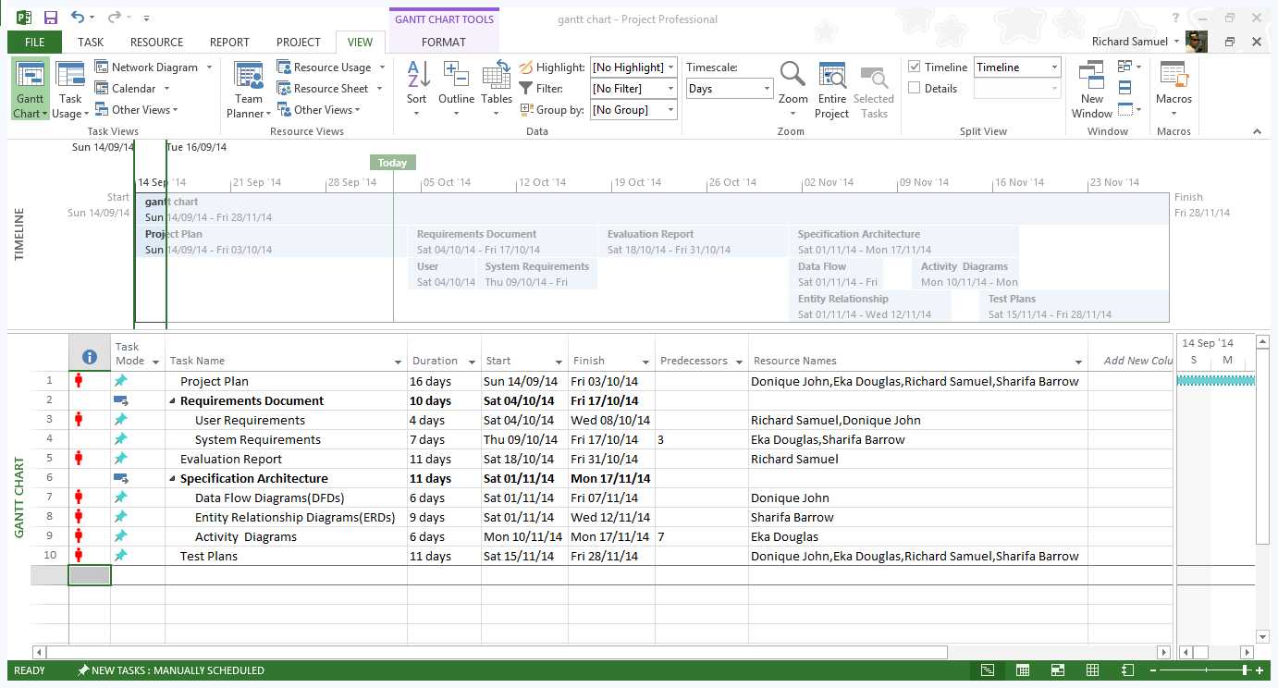

The major milestones are the deliverables. Please refer to section 2.3.

### Iteration Objectives

|  |  |  |
| --- | --- | --- |
| **Deliverables** | **Task** | **Objectives** |
| Project Plan | Developing project plan | * To give a holistic plan of the development of the project |
| Requirements Document | 1. User requirements   ii. System requirements | * To state in natural language as well as to display diagrams of the services to be provided by the systems. * To define a detail description of the system functions and services. |
| Evaluation Report | Protyping the user interface |  |
| Specification Architecture | 1. Data Flows 2. ERD 3. Activity Diagram | * To show the flow of data and how they are to be processed within the system * To show the relationship between the entities in the database in the system. * To show a graphical representation of the activities and actions in the system |
| Test Plan | Creating test plans | * To test scenarios that will show the effectiveness of the system. |

### Releases

[A brief description of each software release and whether it’s demo, beta, and so on.]

### Project Schedule

Please refer to the scheduling table in 4.2 for the project schedule.

### Project Resourcing

The following training will be done

|  |  |
| --- | --- |
| **Training** | **Deadline for training** |
| GIT Hub training | 29.09.2014 |
| Website Protyping | 18.10.2014 |
| Training how to use Microsoft Visio | 1.11.2014 |

## Project Monitoring and Control

**Requirements Management**

The requirements for this system are captured in the Vision document. Requested changes to requirements are captured in Change Requests, and are approved as part of the Configuration Management process.

**Schedule and Budget Control**

The project manager maintains a schedule showing the expected date of each milestone. Checks-up are done every 3-7 days to ensure that each task in on schedule and to determine in the schedule is to be adjusted or if to assigned available team members to help with that task.

**Quality Control**

Defects will be recorded as identified by the client or any team members and adjustments will be made.

All deliverables are required to go through the appropriate review process. The review is required to ensure that each deliverable is of acceptable quality, using guidelines given.

**Reporting and Measurement**

Updated schedule estimates will be generated at the end of each week.

**Risk Management**

The risks will be identified in the project plan and will be evaluated at least once per task and documented in this table.

|  |  |  |  |
| --- | --- | --- | --- |
| Risk | Risk ranking(High, Medium, Low) | Impact | Strategies/Contingencies Plan |
| Change in requirements as project progress. | High | This may increase the time to complete the project. | When gaining requirements from users, analysis can suggest requirements which might may be beneficial and as such maybe implemented earlier |
| File corruption/damage | High | This can cause a big extension to the schedule as the damaged/loss file will need to be recreated | Each file will be backed up on several mediums. |
| Security (hacking) especially on the web components | high | Hackers can gain information about personnel and financial information about the customers and company | Security measures will be put in place. |
| Technological change | Medium | It may be outdated for the latest version of different platforms | The project will be developed around the latest version of each platform. |
| Errors updating the Project plan document. | Medium | It can cause inconsistency and inaccuracy of information if each member tries to update the document at the sametime on the GIT. | The members will be in close communication on when they will make any adjustments to the document before updating using GIT. |

**Configuration Management**

Appropriate tools will be selected which provide a database of all changes made by each user. E.g.: GIT hub.

Full backups are to perform for each file after any change has been made.

# Annexes